Alex Mutebe
MSc. Data Science
Dashboard Presentation

Data visualization dashboard User Manual for a study on Immunization and vaccination for Medical

Introduction

The purpose of the I-VAC dashboard's is to provide principle investigators and other users with an intuitive and thorough user interface that enables them to monitor and assess participant enrolling and follow-up data. The dashboard's purpose is to improve decision-making by offering real-time insights and data analysis.

About this manual
This comprehensive guide will walk you through the various functionalities of the dashboard and help you make the most of the following features
- Visualize the study sites on a map
- Summary of participants’ enrolment numbers
- Distribution of gender across research sites
- Comparing in Age distribution
- Participants’ follow-up trends
- Filtering and drilling down data

Login and Navigation

The I-VAC dashboard can be accessed using the provided URL.
i-vac_dashboard19072023 | Tableau Public

Upon successful login, you will land on the main dashboard page.
Filters
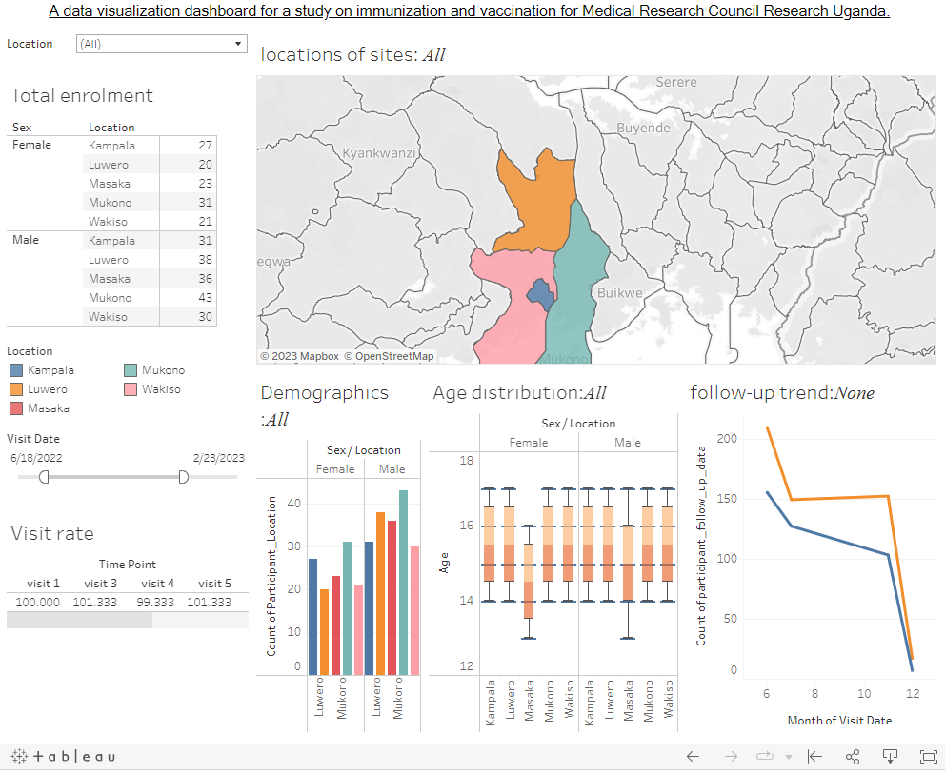
Sites location

Data Visualisation

1.3. Use the navigation menu on the left to access different sections of the dashboard.

Overview Section

- The top left corner on the dashboard shows a quick preview of the participants enrolling. The summary table contains enrolment numbers grouped by sex and location of the enrolling site. Participant follow-up rate is visible at the bottom left. See figure 2

Figure 2 showing participant enrolment Total snapshot
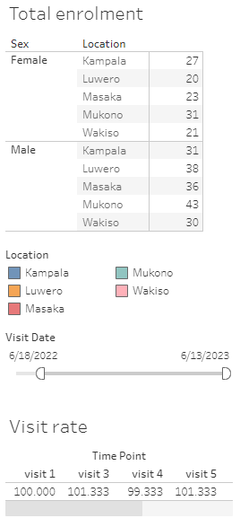
Enrolment number

Percentage of follow-up records

- Explore charts and graphs to get an at-a-glance understanding of performance.
Figure 3. shows location of all the 5 recruiting sites
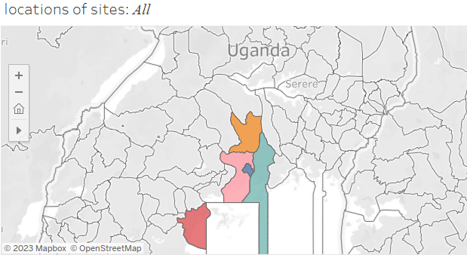

Data Visualization
- The dashboard offers a variety of visualizations, such as bar charts, line graphs, maps, and boxplot. Figure 4 shows bar chart, boxplot and line graph with distribution in sex, age and participant follow-up
Figure 4 shows I-VAC data visualization charts
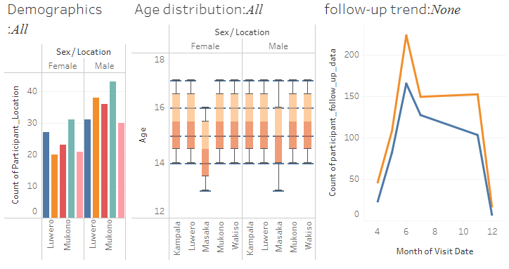

Data Filters
- The dashboard allows you to apply filters to focus on specific data subsets. The location filter includes all sites in a dropdown list combo. Click on the location filter to choose site specific data. See figure 5
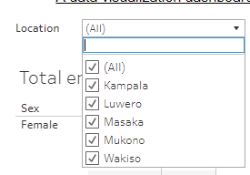
Figure 5 shows location filter

List of sites

- Use the Visit Date filter to view trends in the participants’ follow-up records. Figure 6 shows a slider for adjusting dates. Click and move the points in the slider to choose the visit period you want to see in the line chart.

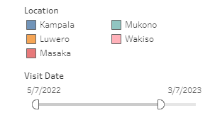
Visit date filter

Combine multiple filters for more precise insights.

You can filter by location and visit date e.g. if you want to view data for only mukono site and visit date ranging from 5/7/2022 to 3/7/2023, select mukono from the location filter and specify the dates on the visit date filter. See figure 7 below showing data for mukono site.
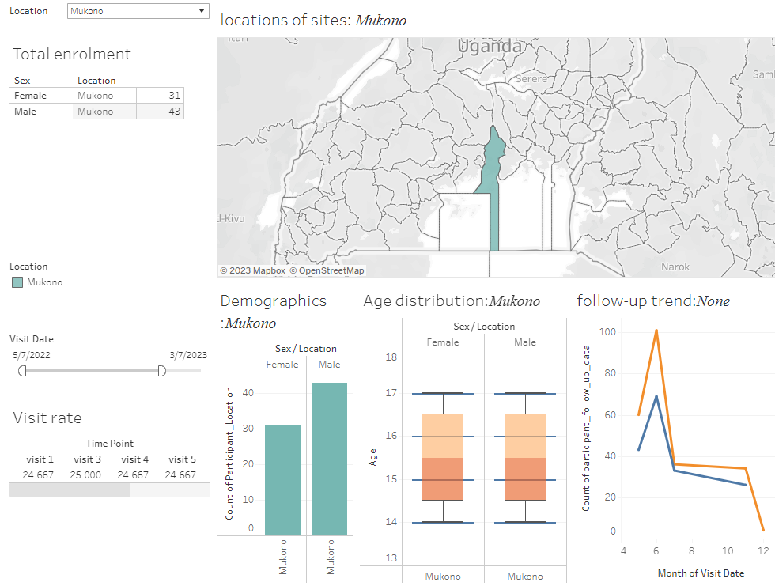

Interact with the visuals to drill down into specific data points.
Click on the map or chart to view details. Figure 8 shows number of enrolled participants’ from masaka site.

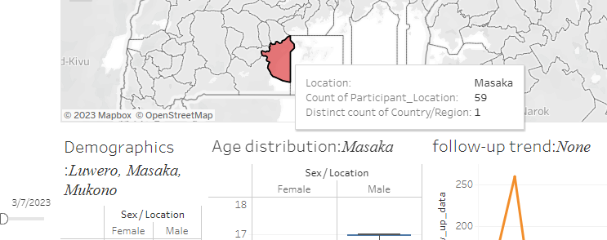

Data Comparison
You can compare the distribution in the number of enrolment with the boxplot. For straightforward sex group comparison, the boxplot displays a side-by-side plot between male and female participants. Figure 9 below shows comparison in age distribution from Masaka site.
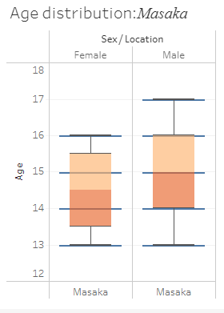

Compare data across different time periods or regions.
Use the Visit date filter to compare follow-data patterns between the male and female participants.
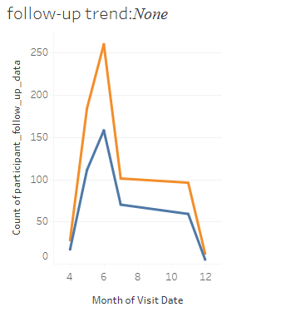
Figure 10 shows a line chart for participant follow-up records between

7.2. Utilize interactive tools to spot trends and patterns.

Downloads
Step 1. Click to download
- Click the download button in the top right corner
- Click the format of the data to download data

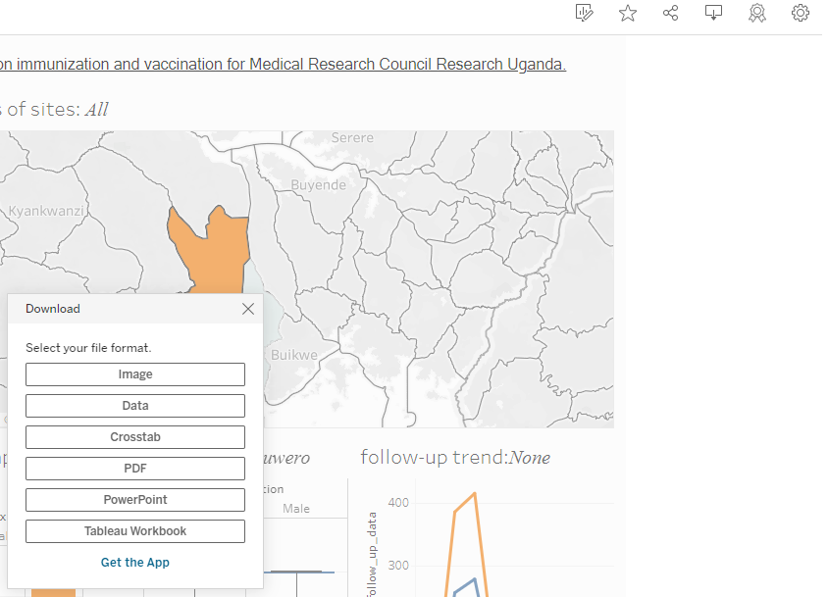

Step 2. Select the data format to download

**8. Collaboration and Sharing**

8.1. Collaborate with team members by sharing the dashboard.

8.2. Assign specific access permissions to control what others can view and edit.

Help
If you encounter any issues, refer to the "Help" section for troubleshooting tips.
Reach out to our support team for assistance and inquiries.

Conclusion
The dashboard will serve as a valuable tool to monitor performance, track progress, and drive success.

